**Lesson Review**

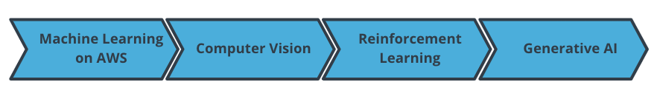

The outline of the lesson

In this lesson, we learned many advanced machine learning techniques. Specifically, we learned:

* Computer vision and its application
* How to train a computer vision project with AWS DeepLens
* Reinforcement learning and its application
* How to train a reinforcement learning model with AWS DeepRacer
* Generative AI
* How to train a GAN and AR-CNN model with AWS DeepComposer

Now, you should be able to:

* Identify AWS machine learning offerings and how different services are used for different applications
* Explain the fundamentals of computer vision and a couple of popular tasks
* Describe how reinforcement learning works in the context of AWS DeepRacer
* Explain the fundamentals of Generative AI, its applications, and three famous generative AI model in the context of music and AWS DeepComposer

;